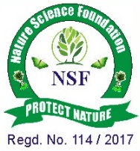
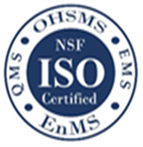

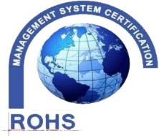
NATURE SCIENCE FOUNDATION
[ISO/IEC 17020:2012 and ISO/IEC 17021:2015 Accredited Inspection
(Reg. No.: IB 121)and Certification (Reg. No.: QM 097) Bodies by
NABCB, QCI, Government of India]
No.2669, LIG-II, Gandhi Managar, Peelamedu, Coimbatore - 641 004, TN, India.
Phone: 0422 4917999, Mobile: 95667 77255, 95667 77258,
Email: director@nsfonline.org.in, website: www.nsfonline.org.in
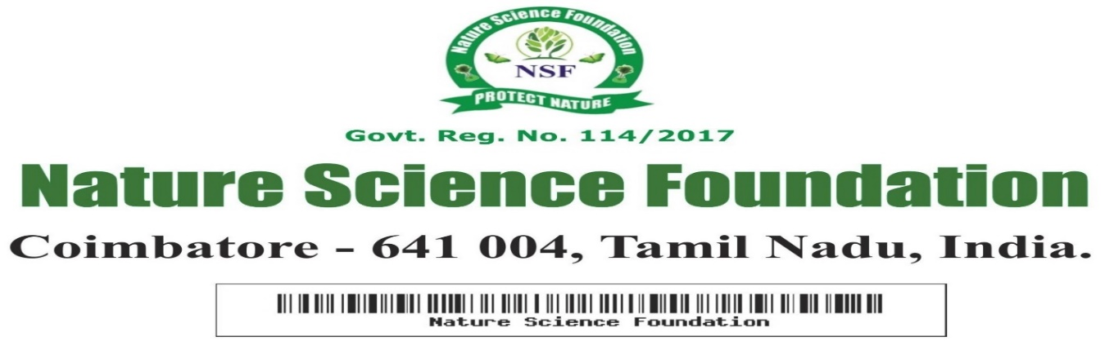
NSF/AEA/2026/02
ACADEMIC EXCELLENCE AWARD


This is to certify that
Dr. Kavitha G. C
Assistant Professor, Department of Studies in Biotechnology
Davangere University, Davangere – 577 007, Karnataka, India
has been honoured with
“Academic Excellence Award”
In Recognition of his exemplary academic excellence and remarkable contributions to enhancing the academic environment having adjudged during academic year 2025-2026 by
Nature Science Foundation, Coimbatore, Tamil Nadu, India.



Chief Executive Officer Director
Nature Science Foundation Nature Science Foundation

