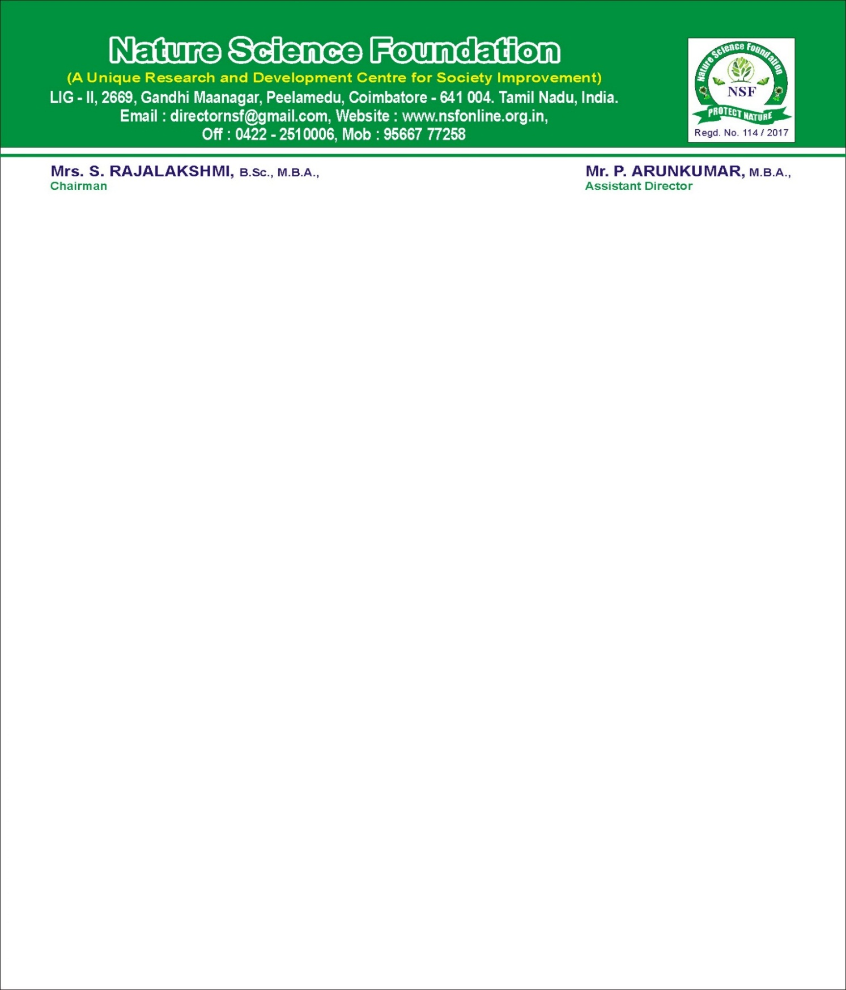

NATURE SCIENCE FOUNDATION
[ISO/IEC 17020:2012 and ISO/IEC 17021:2015 Accredited Inspection (Reg. No.: IB 121)and Certification
(Reg. No.: QM 097) Bodies by NABCB, QCI, Government of India]
No.2669, LIG-II, Gandhi Managar, Peelamedu, Coimbatore - 641 004, TN, India.
Phone: 0422 4917999, Mobile: 95667 77255, 95667 77258,
Email: director@nsfonline.org.in, website: www.nsfonline.org.in
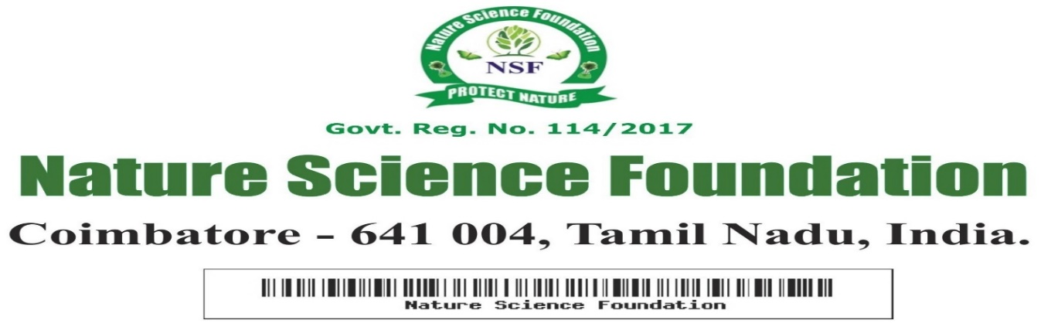

NSF/BCAA/2026/02
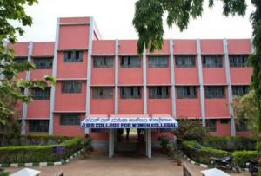

BEST CAMPUS AMENITIES AWARD
This is to certify that JSS College for Women, Kollegal – 571 440, Karnataka, India has been honoured with “Best Campus Amenities Award” for its exceptional work in developing best amenities to all the students in order to succeed academically, to enable excellent leadership quality, and to develop selfless service towards the noble cause of Nature protection during the Academic year 2025-2026 by Nature Science Foundation, Coimbatore, Tamil Nadu, India.



Chief Executive officer Director
Nature Science Foundation Nature Science Foundation

