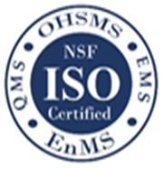
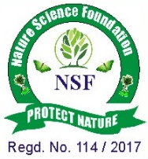

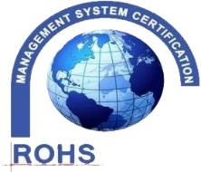
NATURE SCIENCE FOUNDATION
[ISO/IEC 17020:2012 and ISO/IEC 17021:2015 Accredited Inspection
(Reg. No.: IB 121)and Certification (Reg. No.: QM 097) Bodies by
NABCB, QCI, Government of India]
No.2669, LIG-II, Gandhi Managar, Peelamedu, Coimbatore - 641 004, TN, India.
Phone: 0422 4917999, Mobile: 95667 77255, 95667 77258,
Email: director@nsfonline.org.in, website: www.nsfonline.org.in
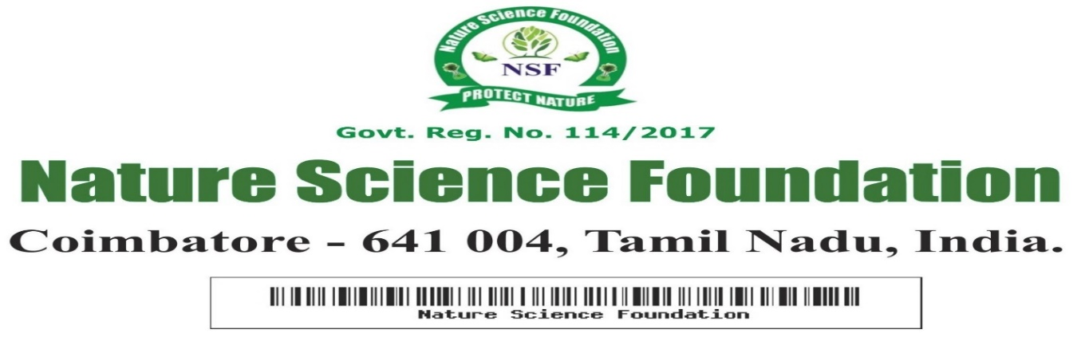

NSF/BAA/2026/01

BEST ADMINISTRATOR AWARD
This is to certify that
Rev. Sr. Arul Devi
Secretary
St. Antony’s College of Arts and Sciences for Women, India
“Best Administrator Award”
For her exceptional contributions have significantly shaped the institution's vision, fostered a culture of excellence, visionary leadership and unwavering commitment to academic excellence having adjudged during Academic year 2025-2026 by Nature Science Foundation, Coimbatore, Tamil Nadu, India.
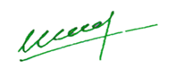

Chief Executive Officer Director Nature Science Foundation Nature Science Foundation

