



Environment Solutions
Dr. M.R. Chandra Mohan Chief Executive Officer

[ISO QMS (9001:2015) & EMS (14001:2015)
Certified and Ministry of MSME Registered Organization]
Chennai – 600 093, Tamil Nadu, India.
Email: environsoln@gmail.com, Mobile: 9042972540

“BEST ECO CLUB AWARD”

is awarded to
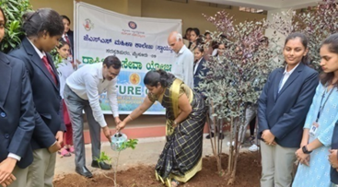

Nature Club

Department of Botany
JSS College for Women (Autonomous)
Saraswathipuram, Mysuru, Karnataka, India in recognition of its outstanding contribution to promoting social responsibility, community engagement, and volunteerism through its Eco Club initiatives. The Eco Club has actively involved students in various outreach programs, awareness campaigns, and community service initiatives, fostering leadership, empathy, and civic responsibility during the Academic Year 2025–2026.


Mr. P. Kanagaraj Secretary

Dr. M.R. Chandra Mohan Chief Executive Officer

