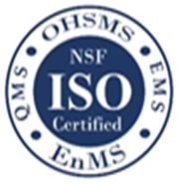
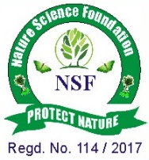
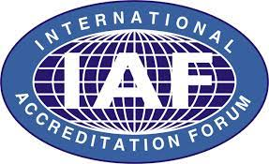
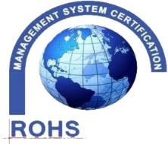
NATURE SCIENCE FOUNDATION
ISO/IEC 17020:2012 and ISO/IEC 17021:2015 Accredited Inspection
(Reg. No.: IB 121)and Certification (Reg. No.: QM 097) Bodies by
NABCB, QCI, Government of India]
No.2669, LIG-II, Gandhi Managar, Peelamedu, Coimbatore - 641 004, TN, India.
Phone: 0422 4917999, Mobile: 95667 77255, 95667 77258,
Email: director@nsfonline.org.in, website: www.nsfonline.org.in
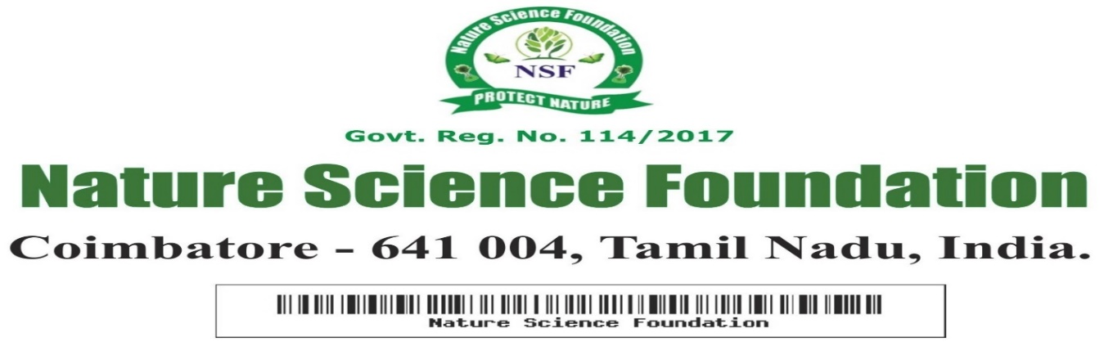

NSF/BEA/2025/27

BEST ENTREPRENEURSHIP AWARD
This is to certify that
Mr. S. Bala Baskar
Assistant Professor, Electronics and Communication Engineering,
St Anne’s College of Engineering and Technology,
Cuddalore – 607 106, Tamil Nadu
has been honoured with
“Best Entrepreneurship Award”
For his outstanding entrepreneurial spirit, innovative business idea, and exceptional leadership skills having adjudged during Academic
year 2025-2026 by Nature Science Foundation,
Coimbatore, Tamil Nadu, India.



Chief Executive Officer Director Nature Science Foundation Nature Science Foundation

