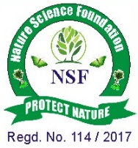
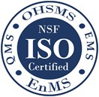

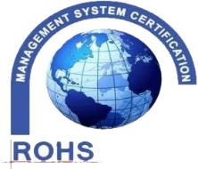
NATURE SCIENCE FOUNDATION
[ISO/IEC 17020:2012 and ISO/IEC 17021:2015 Accredited Inspection
(Reg. No.: IB 121)and Certification (Reg. No.: QM 097) Bodies by
NABCB, QCI, Government of India]
No.2669, LIG-II, Gandhi Managar, Peelamedu, Coimbatore - 641 004, TN, India.
Phone: 0422 4917999, Mobile: 95667 77255, 95667 77258,
Email: director@nsfonline.org.in, website: www.nsfonline.org.in
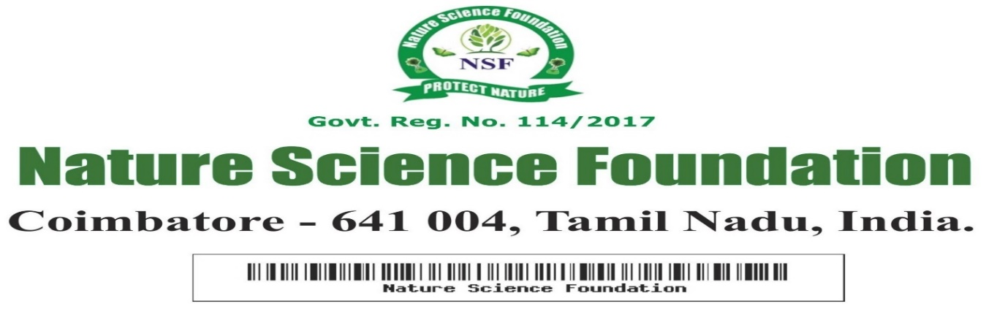
NSF/BEA/2026/02
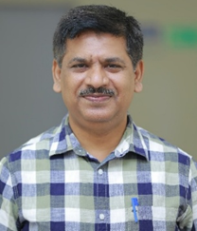

This is to certify that
Dr. Veeresh S J
Assistant Professor, Department of Studies in Food Technology
Davangere University, Davangere – 577 007, Karnataka, India
has been honoured with
“Best Environmentalist Award”
In Recognition of his academic excellence and extraordinary contribution in enhancing the promotion of Environment Conservation and Sustainable Development activities having adjudged during academic year 2025-2026 by Nature Science Foundation, Coimbatore, Tamil Nadu, India.



Chief Executive office Director
Nature Science Foundation Nature Science Foundation

