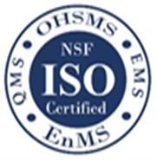
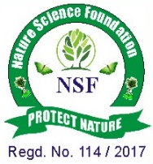
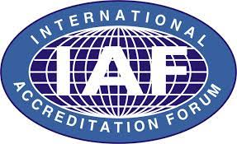
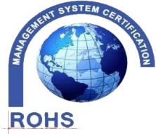
NATURE SCIENCE FOUNDATION
[ISO/IEC 17020:2012 and ISO/IEC 17021:2015 Accredited Inspection
(Reg. No.: IB 121)and Certification (Reg. No.: QM 097) Bodies by
NABCB, QCI, Government of India]
No.2669, LIG-II, Gandhi Managar, Peelamedu, Coimbatore - 641 004, TN, India.
Phone: 0422 4917999, Mobile: 95667 77255, 95667 77258,
Email: director@nsfonline.org.in, website: www.nsfonline.org.in
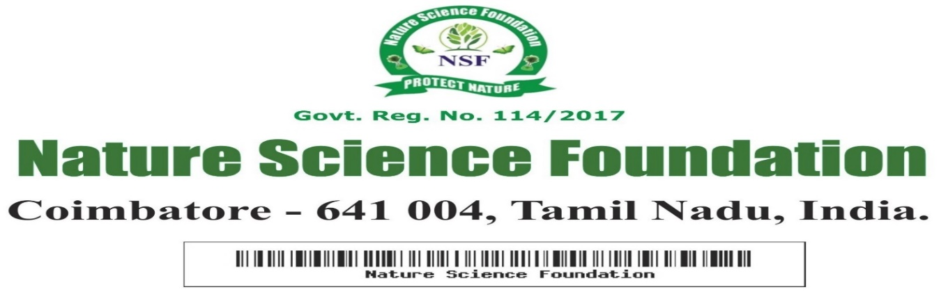

NSF/BPA/2026/05

BEST PRINCIPAL AWARD
This is to certify that
Dr. Kongalappa H S
Principal
JSS College for Women, Kollegal – 571 440, Karnataka, India
“Best Principal Award”
For his Admirable Service as extraordinary contribution in shaping the vision of academic success to all students, Excellent Leadership & Co-ordination within the college processes having adjudged during Academic year 2025-2026 by Nature Science Foundation, Coimbatore, Tamil Nadu, India.


Chief Executive Officer Director Nature Science Foundation Nature Science Foundation

