



Environment Solutions
Dr. M.R. Chandra Mohan Chief Executive Officer

[ISO QMS (9001:2015) & EMS (14001:2015)
Certified and Ministry of MSME Registered Organization]
Chennai – 600 093, Tamil Nadu, India.
Email: environsoln@gmail.com, Mobile: 9042972540

“BEST WOMEN FACULTY AWARD”
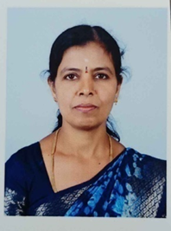

This is to certify that
Smt. Kanaka B
Assistant Professor, Department of Computer Science
JSS College for Women (Autonomous)
Saraswathipuram, Mysuru, Karnataka, India
has been honoured with
“Best Women Faculty Award”
For her Academic excellence and extraordinary contribution
in enhancing the teaching and learning processes in the
field of Computer Science having adjudged during Academic year 2025-2026 by Environment Solutions
Chennai, Tamil Nadu, India.


Mr. P. Kanagaraj Secretary

Dr. M.R. Chandra Mohan Chief Executive Officer

