
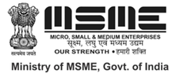
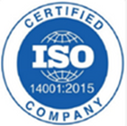

Environment Solutions
Dr. M.R. Chandra Mohan Chief Executive Officer

[ISO QMS (9001:2015) & EMS (14001:2015)
Certified and Ministry of MSME Registered Organization]
Chennai – 600 093, Tamil Nadu, India.
Email: environsoln@gmail.com, Mobile: 9042972540

“BEST WOMEN LEADERSHIP AWARD”
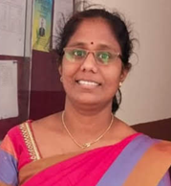

This is to certify that
Dr. K.Dayana
Associate Professor, Department of Basic Science and Humanities,
Jawaharlal College of Engineering and Technology
Lakkidi - 679301, Kerala, India
has been honoured with
“Best Women Leadership Award”
For her exemplary leadership & ability to motivate the team
to produce remarkable results having adjudged during Academic year 2025-2026 by Environment Solutions
Chennai, Tamil Nadu, India.



Mr. P. Kanagaraj Secretary

Dr. M.R. Chandra Mohan Chief Executive Officer

