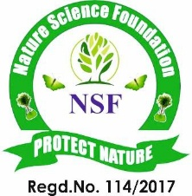


NATURE SCIENCE FOUNDATION
[ISO/IEC 17020:2012 and ISO/IEC 17021:2015 Accredited Inspection (Reg. No.: IB 121)
and Certification (Reg. No.: QM 097) Bodies by NABCB, QCI, Government of India.
No.2669, LIG-II, Gandhi Managar, Peelamedu, Coimbatore - 641 004, TN, India.
Phone: 0422 4917999, Mobile: 95667 77255, 95667 77258,
Email: director@nsfonline.org.in, website: www.nsfonline.org.in

Certificate of Social Responsibility
This certificate is proudly awarded to
DAVANGERE UNIVERSITY
Davangere – 577 007, Karnataka, India
In recognition of outstanding commitment to social responsibility, ethical values and meaningful contributions towards the betterment of society.
The recipient has demonstrated exemplary dedication community engagement and initiatives that promote sustainability, inclusivity and positive social impact.
Ref. No: NSF/SR/F.No.14/2026


Chief Executive Officer Director
Nature Science Foundation Nature Science Foundation

