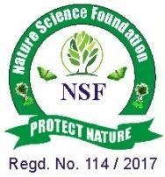


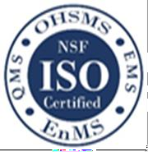
NATURE SCIENCE FOUNDATION
[ISO/IEC 17020:2012 and ISO/IEC 17021:2015 Accredited Inspection
(Reg. No.: IB 121) and Certification (Reg. No.: QM 097) Bodies by NABCB, QCI, Government of India]
No.2669, LIG-II, Gandhi Managar, Peelamedu, Coimbatore - 641 004, TN, India.
Phone: 0422 4917999, Mobile: 95667 77255, 95667 77258,
Email: director@nsfonline.org.in, website: www.nsfonline.org.in

NSF/SRA/2026/01


DR. SARVEPALLI RADHAKRISHNAN AWARD
This is to certify that
Mrs. Sreedevi Kasavajjhala
Assistant Professor (Sanskrit)
St. Ann's College for Women, Mehdipatnam, Hyderabad – 500028, Telangana, India is honoured with
“Dr. Sarvepalli Radhakrishnan Award”
in recognition of his admirable service and extraordinary contribution
in shaping the vision of academic excellence among students, demonstrating exceptional leadership, academic commitment, and
effective coordination in institutional processes having adjudged during the Academic Year 2025-2026 by
Nature Science Foundation, Coimbatore, Tamil Nadu, India.

Chief Executive Officer Director
Nature Science Foundation Nature Science Foundation

