



NATURE SCIENCE FOUNDATION
(A Unique Research and Development Centre for Society Improvement)
An ISO/IEC 17020:2012 Accredited Type ‘A’ Inspection Body by NABCB, QCI, Coimbatore - 641 004, Tamil Nadu, India.
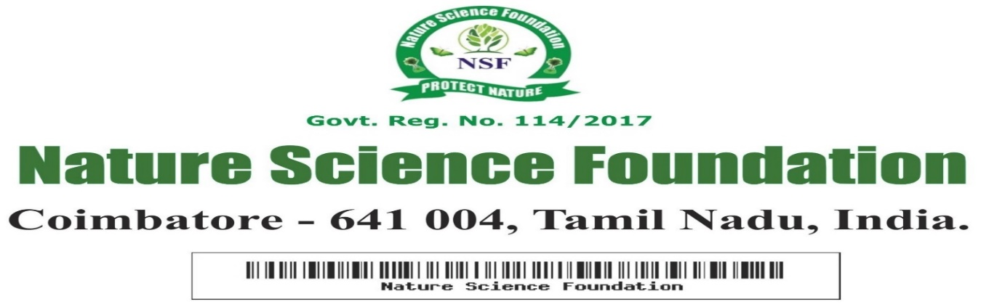
NSF/BEA/2025/35

FELLOW OF NATURE SCIENCE FOUNDATION

This is to certify that
Dr. Sindhu .G.M
Assistant Professor, PG Department of Botany
JSS College of Arts, Commerce and Science
Ooty Road, Mysuru, Karnataka
has been honoured with
“Fellow of Nature Science Foundation”
For her academic excellence and extraordinary contribution in all the activities of Nature Science Foundation having adjudged during Academic year 2024-2025 by Nature Science Foundation, Coimbatore, Tamil Nadu, India.


Chief Executive Officer Director Nature Science Foundation Nature Science Foundation

