
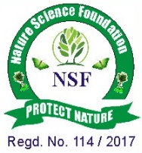

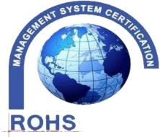
NATURE SCIENCE FOUNDATION
(A Unique Research and Development Centre for Society Improvement)
An ISO/IEC 17020:2012 Accredited Type ‘A’ Inspection Body by NABCB, QCI, Coimbatore - 641 004, Tamil Nadu, India.
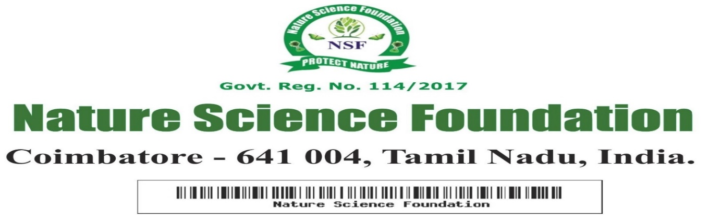
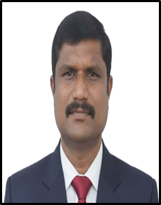
NSF/LTAA/2026/01

LIFE TIME ACHIEVEMENT AWARD
This is to certify that
Dr. C. Gajendran
Professor and Head of the Department,
Civil Engineering,
Jawaharlal College of Engineering and Technology
Lakkidi - 679301, Kerala, India
“Life Time Achievement Award”
his outstanding contributions, dedication, and commitment to excellence in the field Civil Engineering having adjudged during Academic year 2025-2026 by Nature Science Foundation, Coimbatore, Tamil Nadu, India.


Chief Executive Officer Director Nature Science Foundation Nature Science Foundation

