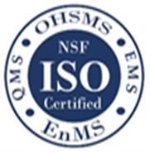
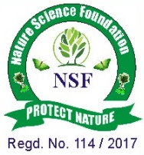
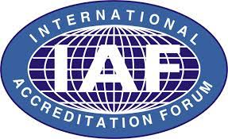
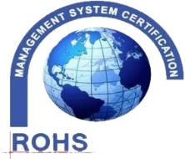
NATURE SCIENCE FOUNDATION
[ISO/IEC 17020:2012 and ISO/IEC 17021:2015 Accredited Inspection
(Reg. No.: IB 121)and Certification (Reg. No.: QM 097) Bodies by
NABCB, QCI, Government of India]
No.2669, LIG-II, Gandhi Managar, Peelamedu, Coimbatore - 641 004, TN, India.
Phone: 0422 4917999, Mobile: 95667 77255, 95667 77258,
Email: director@nsfonline.org.in, website: www.nsfonline.org.in
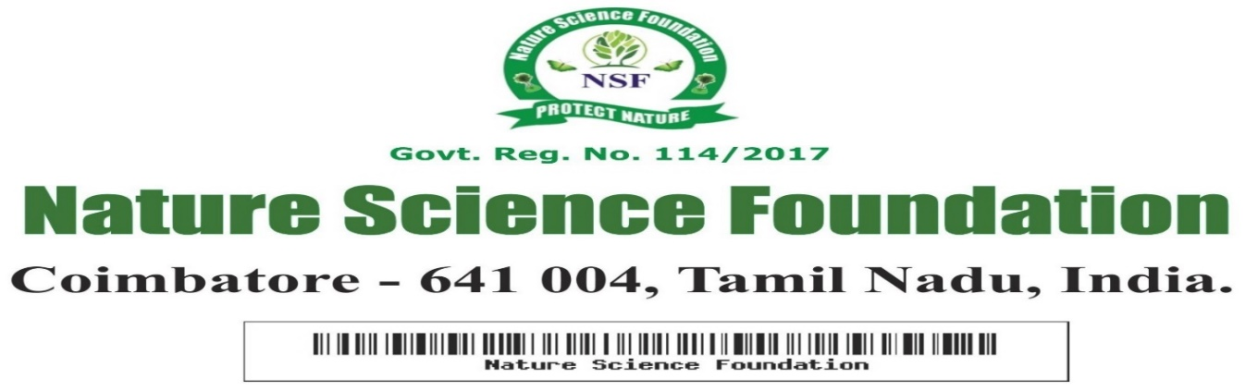

NSF/LTAA/2025/16

LIFE TIME ACHIEVEMENT AWARD
This is to certify that
Dr. R. Arokiadass, M.E., Ph.D.
Principal,
St.Anne’s College of Engineering and Technology,
Cuddalore -607 106, Tamil Nadu
has been honored with
“Life Time Achievement Award”
For his Meritorious Service as extraordinary contribution
in shaping the vision of academic success to all students, Excellent Leadership & Co-ordination within the college processes having adjudged during the Academic year 2025-2026 by Nature Science Foundation, Coimbatore, Tamil Nadu, India




Chief Executive Officer Director Nature Science Foundation Nature Science Foundation

