



Environment Solutions
Dr. M.R. Chandra Mohan Chief Executive Officer

[ISO QMS (9001:2015) & EMS (14001:2015)
Certified and Ministry of MSME Registered Organization]
Chennai – 600 093, Tamil Nadu, India.
Email: environsoln@gmail.com, Mobile: 9042972540

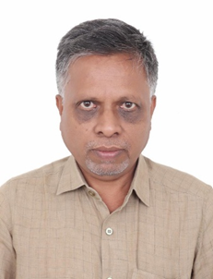
RESEARCH EXCELLENCE AWARD

This is to certify that
Dr. Govindappa M,
Professor
Department of Studies in Botany
Davangere University
Davangere – 577 007, Karnataka, India
has been honoured with
“Research Excellence Award”
In recognition of his academic excellence and exceptional
contributions to research and innovation in the field of
Botany adjudged during Academic year 2024-2025
by Environment Solutions Chennai,
Tamil Nadu, India.


Mr. P. Kanagaraj Secretary

Dr. M.R. Chandra Mohan Chief Executive Officer

